Conceptual design(E-R Diagram)

previous version of ERD

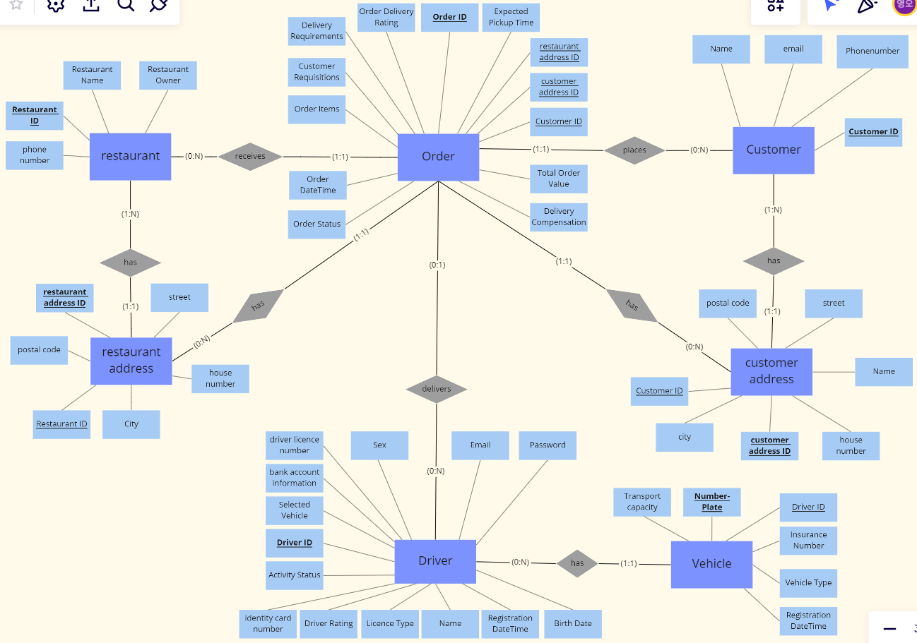

Newly updated version (Final version)

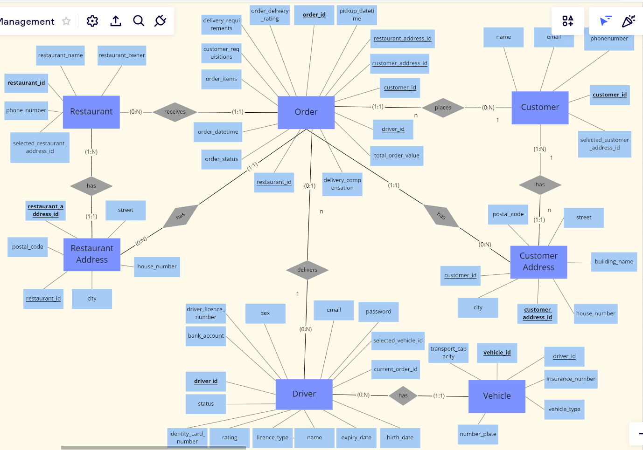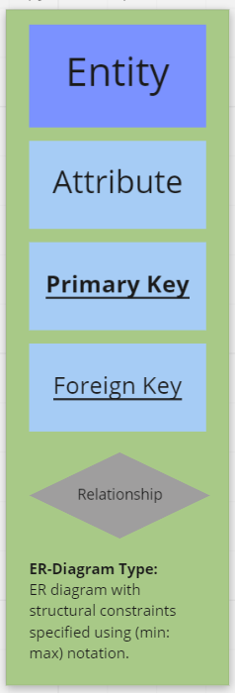

Until the last midterm-project, we identified the need and use of the database, and then modeled the conceptual design with an ER-Diagram. The relationship set between each entity was made using each symbol, and the mapping cardinality was applied to understand the relationship between each entity and define unique data. For the final project, we considered the relationship dependency of data to be designed in the future and modified some attribute of entities.

In detail…

First, we don’t use “registration datetime” attribute of vehicle entity anymore. Considering the driver’s order and the relationship between the vehicles, the vehicle is managed with its own id. As a same way, “driver_id” and “restaurant id” were added to manage its own id. Next, In the customer entity, we added “selected_customer_address_id” to express a more specific mapping relationship with the customer’s address. Then, in the Driver entity, the “status” attribute reduced complexity by assigning more simplified value, and changed to “select” the id of the vehicle to be more normalized and accessible. Lastly, in vehicle entity, we changed the existing “number plate” to “vehicle_id” of prime key, and used NULL to specify the existence and detail of vehicle type and number plate.

Overall, we worked on changing the existing ERD to make it simpler and more accessible.

This task modified the mapping to logical relationships more easily than before, and this process enables the next step of relational databases to be implemented!